Are you more of a liberal or a conservative?

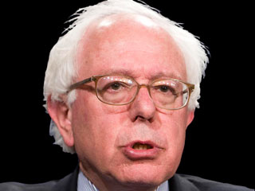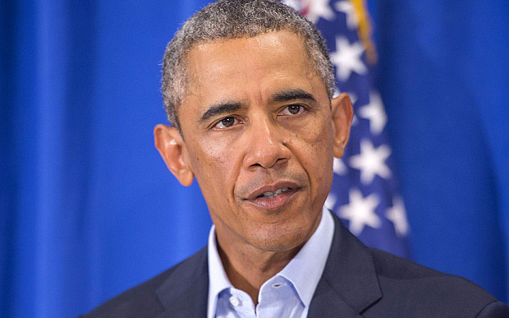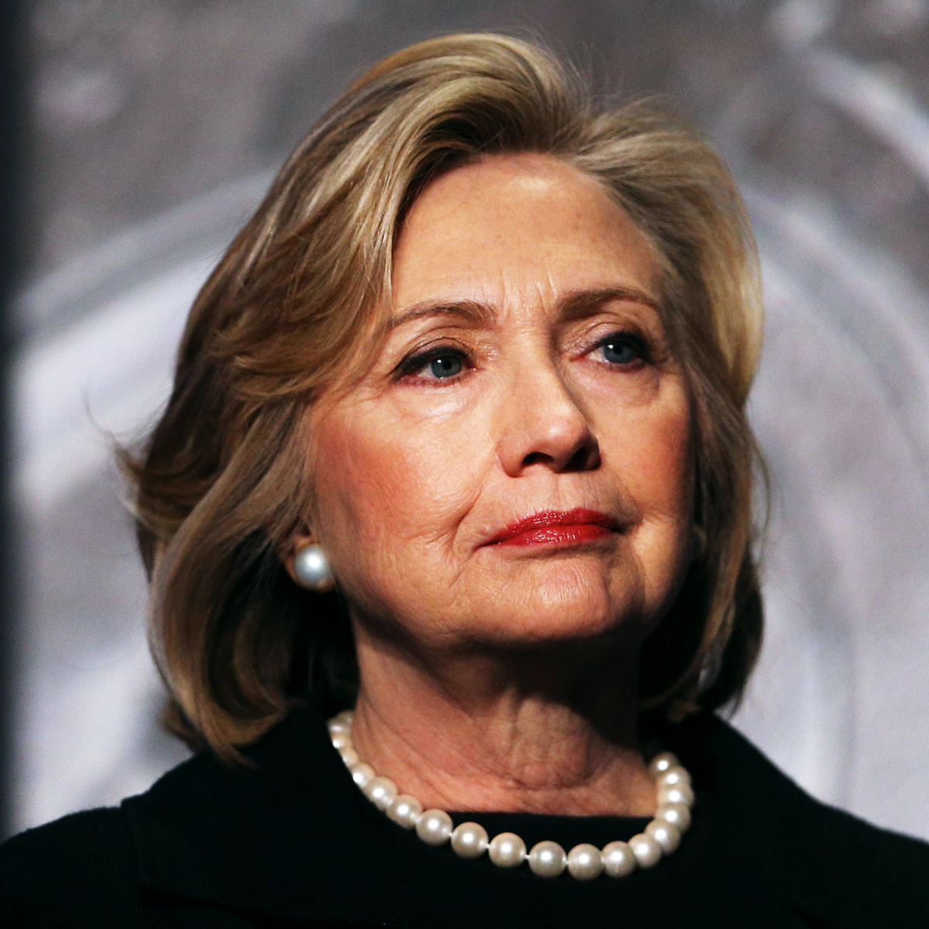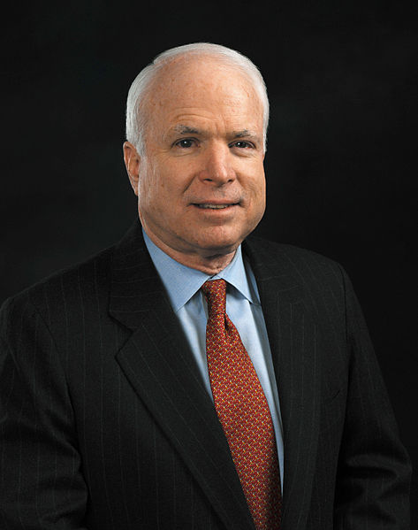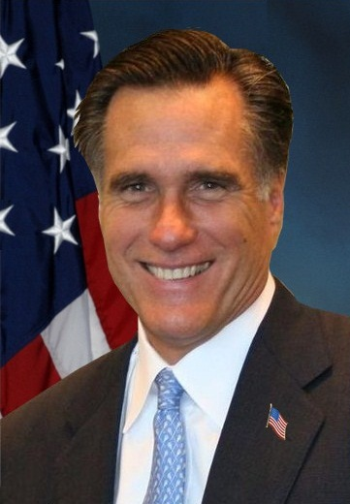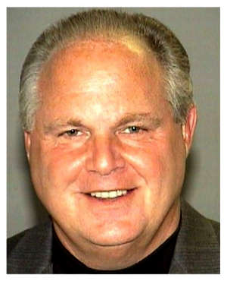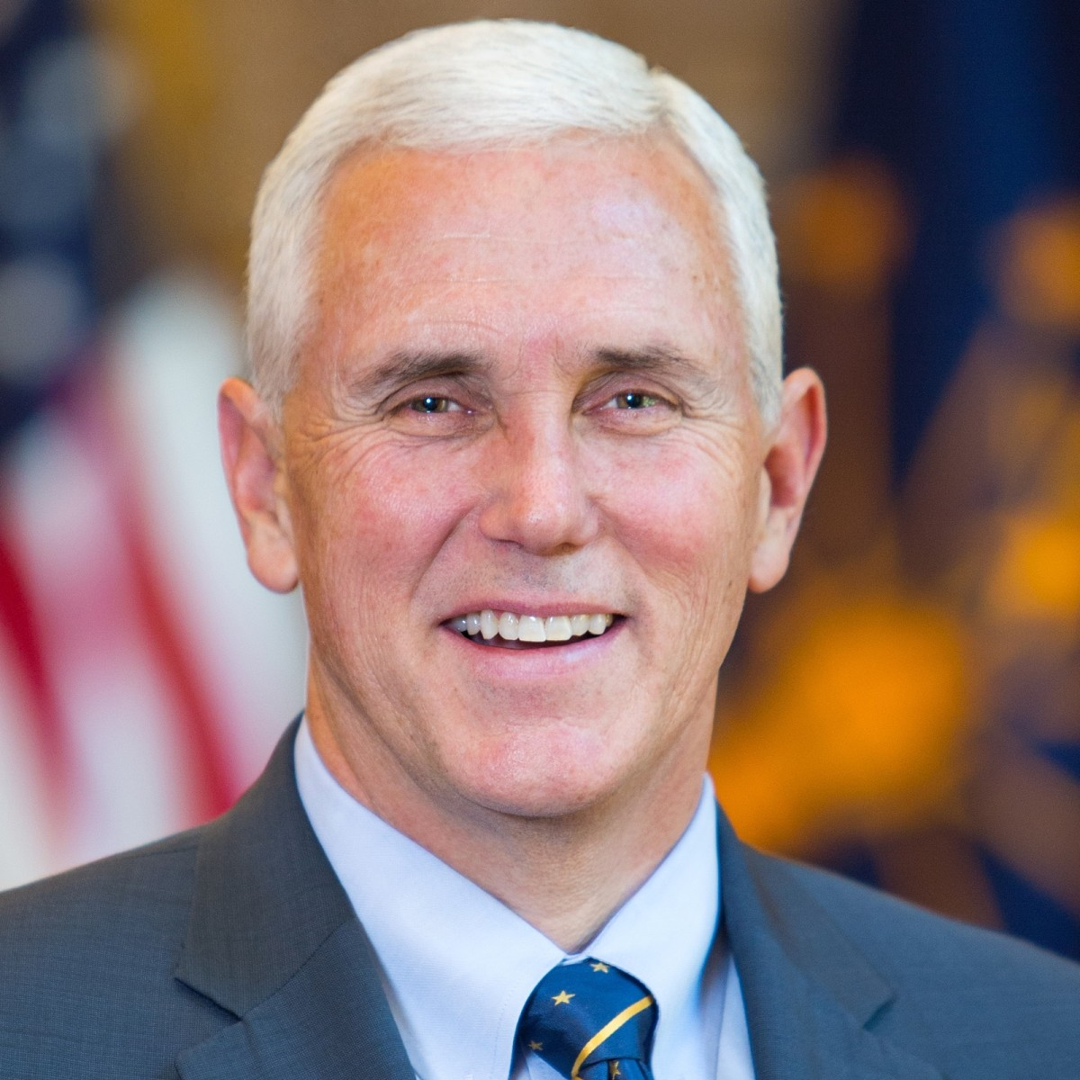

Arnold Rush

Bernie Sanders Kamala Harris Barack Obama Hillary Clinton Schwarzenegger John McCain Mitt Romney Limbaugh Mike Pence

**40-------------------35--------------------30--------------------25------------------20-----------------15------------------10-----------------5-----------------0**

1) Which of the following would you prefer?

1. an activist government which will provide more services, even if it means higher taxes.
2. a smaller government which provides fewer services, but also taxes less.

2) Which laws would you support? (select all that apply.)

1. allow a moment of silence for voluntary prayer in school.
2. ban the sale of handguns other than to the police.
3. ban flag burning.
4. enact term limits for members of Congress.

3) Which type of music do you like better?

1. country and western. b) rap and hip-hop.

4) If you had to watch one or the other, which sport would you watch?

1. Major League Baseball. b) NBA basketball.

5) Which Supreme Court justice is more aligned with your views?

1. Clarence Thomas (pro-life, pro-death penalty, anti-same sex marriage, anti-Obamacare).

b) Ruth Bader Ginsburg (pro-choice, pro-same sex marriage, pro-Obamacare, anti-death penalty).

6) Would you prefer a flat tax, by which all Americans would pay the same percentage of their income in taxes, or a

graduated tax, by which higher incomes are taxed at a higher rate?

1. flat tax. b) graduated tax.

7) Would you be in favor of lower taxes on corporations as a way to try and create more jobs?

1. yes. b) no.

8) Do you believe state laws should be allowed which recognize traditional marriages as the only legal type?

1. yes. b) no.

9) Do you think we should invade countries (such as we did Iraq in 2003) to kick brutal dictators like Saddam Hussein

out of power?

1. yes. b) no.

10) Would you object to the posting of the 10 Commandments in the classrooms at your school?

1. yes. b) no.

11) Who should have a greater voice in deciding which books high school students read in class?

1. teachers. b) parents.

12) Should vaccinations (for things like measles and chicken pox) be mandatory for children who attend public schools?

1. yes. b) no.

13) Should parents who opt to either home school or send their children to private schools be free from having to pay taxes

used by the government to pay for public schools?

1. yes. b) no.

14) Which former president do you prefer?

1. Barack Obama. b) George W. Bush.

15) Which level of government would you prefer to decide on issues such as abortion and the minimum wage?

1. federal. b) state.

16) Should government forms such as voter ballots and driver’s license tests be available in English only?

1. yes. b) no.

17) Should you be allowed to carry a concealed handgun for your own personal protection?

1. yes. b) no.

18) Which of the following welfare ideas would you support? (select all that apply.)

1. a two-year cutoff for welfare recipients who do not find jobs.
2. additional funding for job training programs for welfare recipients.
3. mandatory drug testing for welfare recipients with a reduction of benefits for drug users.
4. additional funding for child care programs so that welfare recipients can take jobs.

19) Which of the following should we do in order to cut the budget deficit? (select all that apply.)

1. cut Social Security and Medicare benefits.
2. cut loans to college students.
3. cut subsidies to PBS and the arts.
4. cut defense spending.

20) Should undocumented immigrants be eligible for welfare benefits for their children?

1. yes. b) no.

21) Do you approve of “three strikes” laws whereby anyone convicted of three felonies is sent to prison for life?

1. yes. b) no.

22) Which is closer to your opinion?

1. the environment should be protected even if it risks jobs in certain industries such as oil and coal.
2. a higher priority should be placed on the protection of jobs than on the protection of the environment.

23) Should the minimum wage be increased?

1. yes. b) no.

24) Should high schools teach subjects like evolution and sex education which conflict with the religious values of some

families?

1. yes. b) no.

25) Should sports teams such as the Washington Redskins and the Cleveland Indians whose names and mascots offend

certain minority groups be required to switch to something less offensive?

1. yes. b) no.

26) Are you in favor of the death penalty?

1. yes. b) no.

27) If they commit the most serious crimes, should juveniles as young as 16 be judged as adults in criminal cases?

1. yes. b) no.

28) Should employers be allowed to fire workers who go on strike and permanently replace them or should they be required by

law to negotiate with the striking workers?

1. fire them. b) required to negotiate.

29) Should elected officials be able to spend government money at businesses they own (such as hosting a dinner at their

own restaurant or staying in their own hotel on a road trip)?

1. yes. b) no.

30) Which abortion laws do you agree with? (select all that apply.)

1. mandatory notification before an abortion of the parents of anyone under 18.
2. no government funding for neighborhood health clinics which perform abortions.
3. allow abortions only in the instance of rape, incest, or danger to the life of the mother.
4. abortions should not be restricted by the government.

**SCORING: Points are added for more liberal responses. The more conservative option scores a zero.**

**Figure your score and then see where you fall on the political spectrum at the top**

**of the survey.**

1) a = 2 points, b = 0 points. 16) a = 0, b = 1

2) a = 0, b = 1, c = 0, d = 0 17) a = 0, b = 2

3) a = 0, b = 1 18) a = 0, b = 1, c = 0, d = 1

4) a = 0, b = 1 19) a = 0, b = 0, c = 0, d = 1

5) a = 0, b = 1 20) a = 1, b = 0

6) a = 0, b = 1 21) a = 0, b = 1

7) a = 0, b = 1 22) a = 2, b = 0

8) a = 0, b = 1 23) a = 2, b = 0

9) a = 0, b = 2 24) a = 1, b = 0

10) a = 1, b = 0 25) a = 1, b = 0

11) a = 1, b = 0 26) a = 0, b = 2

12) a = 1, b = 0 27) a = 0, b = 1

13) a = 0, b = 1 28) a = 0, b = 1

14) a = 2, b = 0 29) a = 0, b = 1

15) a = 2, b = 0 30) a = 0, b = 0, c = 0, d = 2

**SCORING: Points are added for more liberal responses. The more conservative option scores a zero.**

**Figure your score and then see where you fall on the political spectrum at the top**

**of the survey.**

1) a = 2 points, b = 0 points. 16) a = 0, b = 1

2) a = 0, b = 1, c = 0, d = 0 17) a = 0, b = 2

3) a = 0, b = 1 18) a = 0, b = 1, c = 0, d = 1

4) a = 0, b = 1 19) a = 0, b = 0, c = 0, d = 1

5) a = 0, b = 1 20) a = 1, b = 0

6) a = 0, b = 1 21) a = 0, b = 1

7) a = 0, b = 1 22) a = 2, b = 0

8) a = 0, b = 1 23) a = 2, b = 0

9) a = 0, b = 2 24) a = 1, b = 0

10) a = 1, b = 0 25) a = 1, b = 0

11) a = 1, b = 0 26) a = 0, b = 2

12) a = 1, b = 0 27) a = 0, b = 1

13) a = 0, b = 1 28) a = 0, b = 1

14) a = 2, b = 0 29) a = 0, b = 1

15) a = 2, b = 0 30) a = 0, b = 0, c = 0, d = 2